Chinook Cycling Club
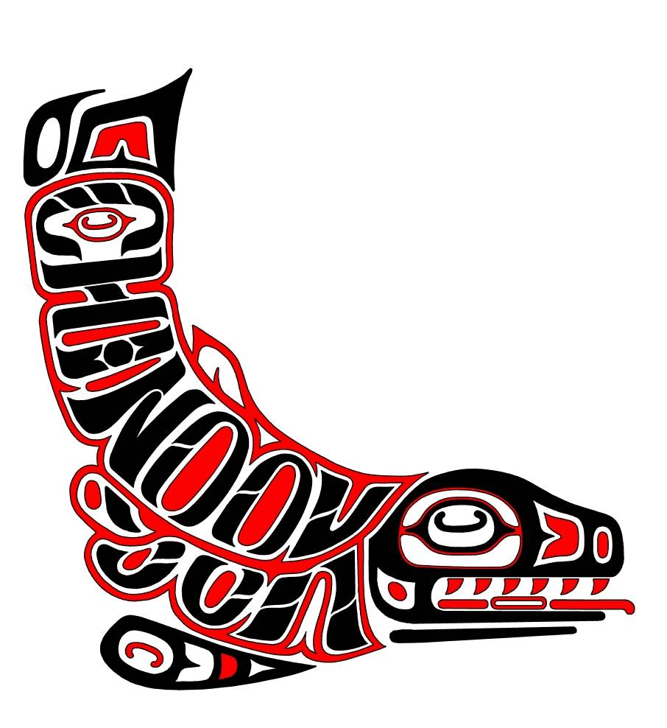

Tri-Cities, WA

www.chinookcyclingclub.com

2015 CHINOOK CYCLING CLUB MEMBERSHIP APPLICATION
(calendar year membership period)

Name: _______________________________________________________________
Please list all names included in family membership: _________________________________________
Address: _______________________________________________________________
City, St., Zip: _______________________________________________________
Phone: ______________________________ E-mail: ____________________________________________
Chinook Cycling Club does not share any of the above information outside the club.
To receive e-mail notices of club news, activities, and events: Log onto the club webpage and create an account with user name and password.
Interest(s): - MTB - Road – Cyclo-cross: Racing - Touring - Other________________________
Membership Options: (check only one, make checks payable to: Chinook Cycling Club)
_______ INDIVIDUAL MEMBERSHIP - $45.00
_______FAMILY MEMBERSHIP - $60.00 (For immediate family, including children under the age of 21 years)
_______INDIVIDUAL YOUTH MEMBERSHIP - $15.00 (For young riders, 17 years old or younger as of December 31, 2015)
_______ONE DAY MEMBERSHIP - $15.00 (If an additional 1 day membership is needed, the cost will be the balance of full membership price. This entitles the new member to full membership privileges for the remainder of the calendar year.)
Note: Participation in all 2015 Chinook Cycling Club Events: Spring Road Series, Time Trial Series, and Fall Mountain Bike Series are included in membership. Chinook Cycling Club membership fee does not include USA CYCLING membership fees.
I agree to wear an ANSI and or SNELL approved helmet when participating in any club cycling activity.

Signature: ______________________________________________________ Date:_____________________
Form prints onto an 8.5" x 11" sheet of paper. Please print and fill out the 2015 Waiver and Release of Liability for each member and attach with this form. Make checks payable to: “Chinook Cycling Club”, and mail to:
Chinook Cycling Club
2120 Hamilton Ave
Richland, WA 99354
Revised 12/15/2015

